C PROGRAMMING TO FIND SUM OF ODD NUMBERS THE FIRST N NUMBERS

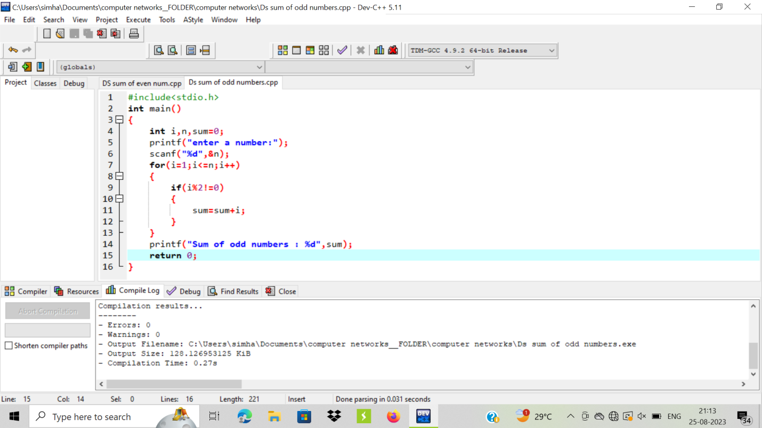

OUTPUT:

